2022-23 SUS Admissions Tour MATRIX
Universities | 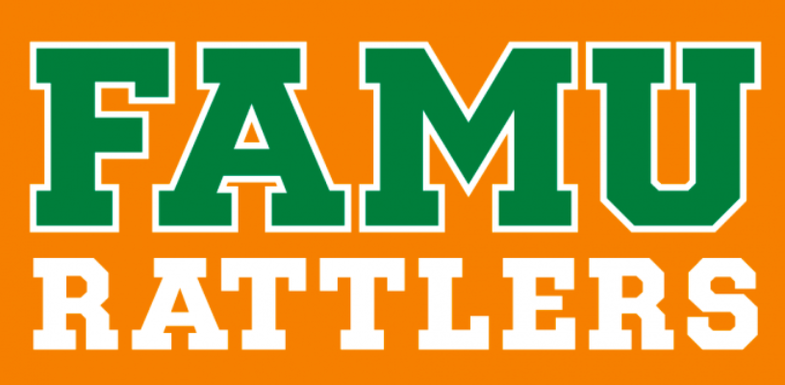 |  | 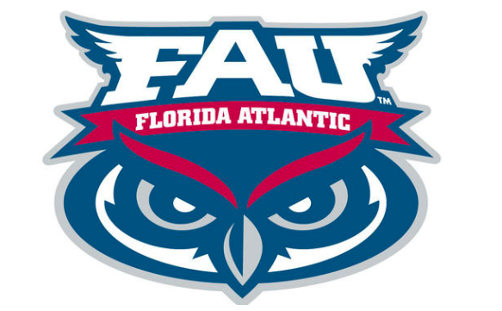 | 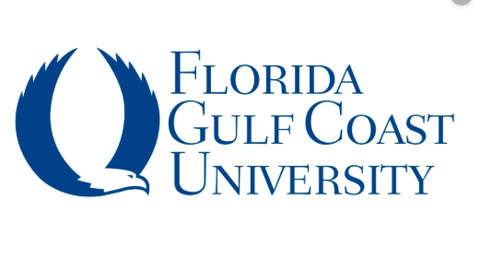 | 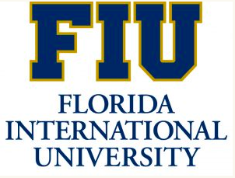 | 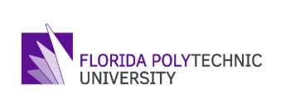 | 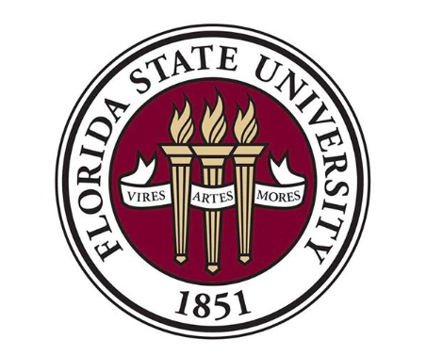 | 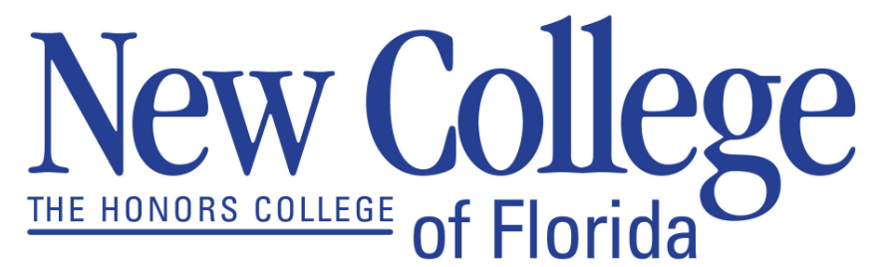 | 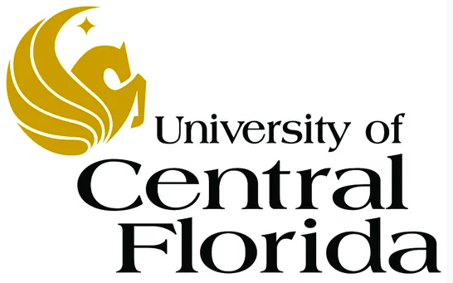 | 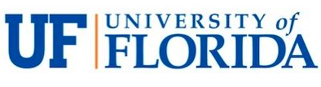 | 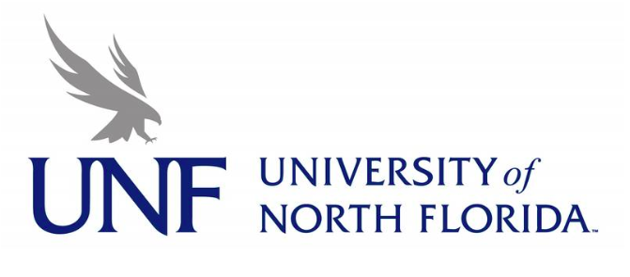 | 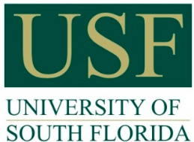 | 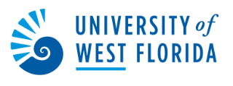
Name/  Location | Florida Agricultural and Mechanical University  Tallahassee |  | Florida Atlantic University  Boca Raton | Florida Gulf Coast University  Ft. Myers | Florida International University  Miami | Florida Polytechnic University  Lakeland | Florida State University  Tallahassee | New College of Florida  Sarasota | University of Central Florida  Orlando | University of Florida Gainesville | University of North Florida Jacksonville | University of South Florida  Tampa | University of West Florida Pensacola
Type of Applications Accepted | Institutional Only |  | Institutional or Common App | Institutional or Common App | Institutional Only | Institutional or Common App | Institutional or Common App | Institutional or Common App | Institutional or Common App | Common App | Institutional or Common App | Institutional or Common App | Institutional or Common App
Middle 50% of Admitted FTIC 2022  (S=Summer) (F=Fall) | GPA | S: 3.5  F: 3.77 | S: 3.23 - 3.80  F: 3.70 - 4.30 | S: 3.56 – 4.4  F: 3.56 – 4.33 | S: 3.9 - 4.4  F: 4.2 - 4.7 | S: 3.8 - 4.4  F: 4.0 - 4.7 | S: 4.0 - 4.4  F: 4.3 - 4.6 | F: 3.8 - 4.4 | S: 3.8 - 4.3  F: 3.9 - 4.4 | S: 4.4 - 4.6  F: 4.4 - 4.6 | S: 3.37 – 4.0  F: 3.6 - 4.39 | S: 3.62 – 4.12  F: 4.0 – 4.5 | S: 3.4 – 4.05  F: 3.5 – 4.18
 | SAT | S: 1020  F: 1110 | S: 1000 - 1120  F: 1090 - 1260 | S: 1010 -1170  F: 1090 - 1240 | S: 1070 - 1170  F: 1250 - 1380 | S: 1140 - 1250  F: 1290 - 1410 | S: 1180 - 1300  F: 1300 - 1430 | F: 1110 - 1320 | S: 1150 - 1270  F: 1250 - 1370 | S: 1240 - 1420  F: 1370 - 1500 | S: 1110  F: 1135 | S: 1100 - 1190  F: 1240 - 1390 | S: 1050 - 1170  F: 1050 - 1220
 | ACT | S: 16  F: 18 | S: 20 - 23  F: 22 - 28 | S: 19 - 24  F: 21 - 27 | S: 21 - 24  F: 26 - 30 | S: 22 - 27  F: 27 - 32 | S: 25 - 29  F: 29 - 32 | F: 22 - 29 | S: 23 - 27  F: 26 - 30 | S: 28 - 32  F: 31 - 34 | S: 22  F: 24 | S: 22 - 25  F: 27 - 31 | S: 21- 25  F: 21 - 27
Transcript | SSAR |  | SSAR | Send official transcript | Send official transcript | SSAR | SSAR | SSAR | Uses SPARK | SSAR | SSAR | SSAR | SSAR
Application Deadline 1  Priority | 11/1 |  | 11/1 | 11/1 | 11/1 | 11/1 | 10/15 | 11/1 | 12/1 | 11/1 | 11/1 | 11/1 | 12/1
Decision Release 1 | 9/16 |  | 10/1 | 12/1 | Rolling | 11/15 | 12/15 | Rolling | Rolling | 2/24 | Rolling | 12/15 | 10/15
Application Deadline 2 |  |  |  |  |  |  | 12/1 | 3/1 | 3/1 | 3/1 |  | 3/1 | 12/1
Decision Release 2 | Rolling |  | Rolling | Rolling | Rolling |  | 2/15 | Rolling | Rolling | 3/24 | Rolling | Rolling | Rolling
Application Deadline  Final | 5/1 |  | 4/1 | 3/1 | 4/1 | 3/1 | 3/1 | 4/1 | 5/1 |  | 5/1 |  | 6/1
Scholarship  Application Deadline | 11/1 |  | 1/15 | 11/1 | 11/15 | 11/1 | 12/1 | 2/1 | 11/1 | 11/1 | 10/15 | 1/15 | 12/1
Transfer:  2+2 Enhancement Programs | Ignite Program |  | Link | Destination FGCU | Connect- 4Success | Polk State College & South Florida State College (EE) | TCC2FSU | Guaranteed Admission Program | DirectConnect to UCF | Gator Engineering; Gator Design and Construction | SF2UNF;  FSCJ/UNF Connect; UNF/SJR State Gateway | FUSE | 2UWF

