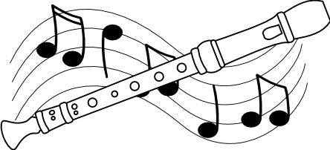
ATTENTION 3rd, 4th & 5th GRADERS!

IT’S RECORDER TIME!!!

For those who do not have a recorder yet, one must be purchased from Mrs. DuQuette, Ms. Guidry or Mrs. Walukonis so that you will be able to participate in music class activities during the school year.
THIS IS A REQUIRED PART OF OUR MUSIC CURRICULUM AT ODESSA.

We sell excellent quality Yamaha recorders for $6.00 and the Recorder Express book by Artie Almeida for $6.00. However, we encourage you to use an older sibling’s recorder book and even their recorder if available. If you wish to purchase a second recorder for any reason, that will be an additional $6.00.

Please include cash or a check made out to Odessa Elementary (phone number and student 6 digit ID number too!) with this order form and have your child give it directly to his/her music teacher.

Please contact us if you have any questions or concerns.

Student name (print)_____________________________________Grade/Teacher__________________
Parent name (print)_________________________________________________Ph#__________________

_________I am purchasing one book and recorder package for $12.00

_________I am purchasing ________book(s) for $6.00 each

_________I am purchasing ________recorder(s) for $6.00 each

TEACHER USE ONLY……………………………………………………………………

Total books sold_________________ Total recorders sold_____________
Cash received total_______________
Check received total_______________ Check #____________________
Student received items on ___________________
Teacher initials__________________

