Schoolhouse Rock Lyrics: 2nd and 3rd Grades
Monday, March 14, 2016

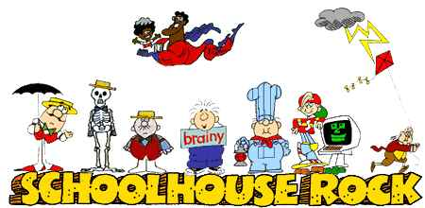

Three Is A Magic Number
One, two, three…
Three is a magic number,
Yes it is, it's a magic number.
Somewhere in the veil of ancient history,
You get three as a magic number.
The past and the present and the future.
Faith and Hope and Charity,
The heart and the brain and the body,
Give you three as a magic number.
A man and a woman had a little baby,
Yes, they did.
They had three in the family,
And that's a magic number.
3-6-9, 12-15-18, 21-24-27, 30.
3-6-9, 12-15-18, 21-24-27, 30.
Multiply backwards from 3 x 10:
3 x 10 is 30, 3 x 9 is 27, 3 x 8 is 24, 3 x 7 is 21,
3 x 6 is 18, 3 x 5 is 15, 3 x 4 is 12,
And 3 x 3 is 9, and 3 x 2 is 6,
And 3 x 1, that’s a magic number.

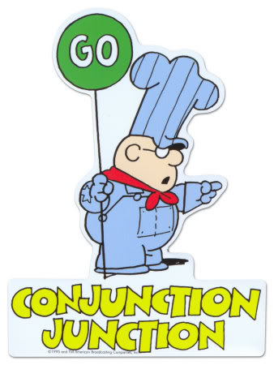

Conjunction Junction
Conjunction Junction, what's your function?
Hooking up words and phrases and clauses.
Conjunction Junction, how's that function?
I got three favorite cars
That get most of my job done.
Conjunction Junction, what's their function?
I got "and", "but", and "or",
They'll get you pretty far.
[spoken] "And":
That's an additive, like "this and that".
"But":
That's sort of the opposite,
"Not this but that".
And then there's "or":
O-R, when you have a choice like
"This or that".
"And", "but", and "or",
Get you pretty far.
[sung] Conjunction Junction, what's your function?
Hooking up two boxcars and making 'em run right.
Milk and honey, bread and butter, peas and rice.
Hey that's nice!
Dirty but happy, digging and scratching,
Losing your shoe and a button or two.
He's poor but honest, sad but true,
Boo-hoo-hoo-hoo-hoo!
Conjunction Junction, what's your function?
Hooking up two cars to one
When you say something like this choice:
"Either now or later"
Or no choice:
"Neither now nor ever"
Hey that's clever!
Eat this or that, grow thin or fat,
Never mind, I wouldn't do that,
I'm fat enough now!
Conjunction Junction, what's your function?
Hooking up phrases and clauses that balance, like:
Out of the frying pan and into the fire.
He cut loose the sandbags,
But the balloon wouldn't go any higher.
Let's go up to the mountains,
Or down to the seas.
You should always say "thank you",
Or at least say "please".
Conjunction Junction, what's your function?
Hooking up words and phrases and clauses
In complex sentences like:
[spoken] In the mornings, when I'm usually wide awake, I love to take a walk through the gardens and down by the lake, where I often see a duck and a drake, and I wonder, as I walk by, just what they'd say if they could speak, although I know that's an absurd thought.
Conjunction Junction, what's your function?
Hooking up cars and making 'em function.
Conjunction Junction, how's that function?
I like tying up words and phrases and clauses.
Conjunction Junction, watch that function.
I'm going to get you there if you're very careful.
Conjunction Junction, what's your function?
I'm going to get you there if you're very careful.
Conjunction Junction, what's your function?
I'm going to get you there if you're very careful.

A Noun is a Person, Place, or Thing
Well every person you can know,
And every place that you can go,
And anything that you can show,
You know they're nouns.
A noun's a special kind of word,
It's any name you ever heard,
I find it quite interesting,
A noun's a person, place, or thing.
Oh I took a train, took a train to another state.
The flora and the fauna that I saw were really great.
When I saw some bandits chasin' the train.
I was wishin' I was back home again.
I took a train, took a train to another state.
Well, every person you can know (Like a bandit or an engineer)
And every place that you can go (Like a state or a home)
And anything that you can show (Like animals and plants or a train)
You know they're nouns - you know they're nouns, oh...
I took a ferry to the Statue of Liberty.
My best friend was waitin' there for me. (He took an early ferry.)
We went for a walk on the island you know,
And in the middle of summer it started to snow,
When I took a ferry to the Statue of Liberty.
Well every person you can know (Like a friend or the captain of a ship)
And every place that you can go (Like an island or a sea)
And anything that you can show (Like a statue, a ferry, or snow)
You know they're nouns - you know they're nouns.
Oh, I put a dime in the drugstore record machine.
Oldie goldies started playing if you know what I mean.
I heard Chubby Checker, he was doin' the twist
And the Beatles and the Monkees, it goes like this, yeah!
I put a dime in the drugstore record machine.
Well every person you can know (The Beatles and the Monkees, Chubby Checker)
And every place that you can go (Like a neighborhood or a store)
And anything that you can show (Like a dime or a record machine)
You know they're nouns.
A noun's a special kind of word,
It's any name you ever heard,
I find it quite interesting,
A noun's a person, place, or thing.
A noun is a person, place or thing.
(doodle, doodleh; doodle doodleh...)

Interplanet Janet
They say our solar system is centered around the sun,
Nine planets, large and small, parading by.
But somewhere out in space,
There's another shining face
That you might see some night up in the sky waving hi.
Interplanet Janet, she's a galaxy girl,
A solar system Miss from a future world,
She travels like a rocket with her comet team
And there's never been a planet Janet hasn't seen,
No, there's never been a planet Janet hasn't seen.
She's been to the Sun, it's a lot of fun, (hi!)
It's a hot-spot, It's a gas!
Hydrogen and helium in a big, bright, glowing mass.
It's a star, it's a star! So Janet got an autograph!
Uh-huh!
Mercury was near the Sun so Janet stopped by,
But the mercury on Mercury was much too high, so
Janet split for Venus but on Venus she found
She couldn't see a thing for all the clouds around.
Earth looked exciting, kind of green and inviting,
So Janet thought she'd give it a go.
But the creatures on that planet looked so very weird to Janet,
She didn't even dare to say hello.
It's a bird, it's a plane! Why, it must be a UFO, but it was:
Interplanet Janet, she's a galaxy girl,
A solar system Miss from a future world,
She travels like a rocket with her comet team
And there's never been a planet Janet hasn't seen,
No, there's never been a planet Janet hasn't seen.
Mars is red and Jupiter's big
Saturn shows off its rings.
Uranus is built on a funny tilt
And Neptune is its twin,
And Pluto, little Pluto, is the farthest planet from our Sun.
Interplanet Janet, she's a galaxy girl,
A solar system Ms. from a future world,
She travels like a rocket with her comet team
And there's never been a planet Janet hasn't seen,
No, there's never been a planet Janet hasn't seen.

