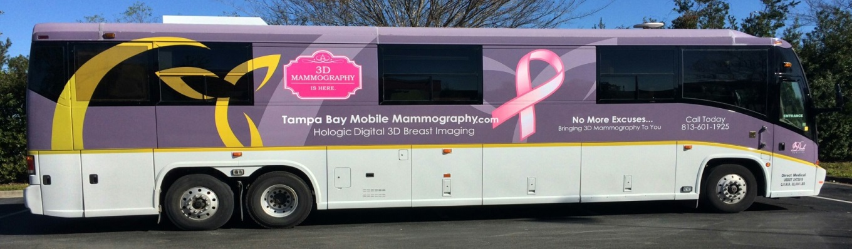

1 in 8 women will be diagnosed with Breast Cancer in their lifetime.

Pasco County Schools has partnered Tampa Bay Mobile Mammography to bring 3D Mammography to You
Early detection saves lives—get scanned

Tampa Bay’s Mobile Mammography Bus will be at your school or worksite on:
Date:

Time:

Eligibility Requirements:

- No prescription or referral required if:
  - Age 40 or older
  - No prior mammogram in current calendar year

- Physician referral required if:
  - Under the age of 40

PLEASE Schedule online:

www.PascoMammo.com

Questions? 813-601-1925

