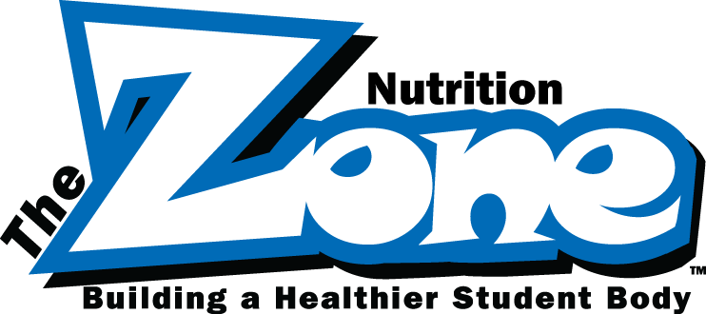
FNS CLASS DESCRIPTIONS
===============================
Summer 2017

2000 OPERATIONS

2621-101-0816: Temp Takers, 2 CEUs

9:00am – 11am July 6, 2017
12:00pm – 2:00pm July 6, 2017

Open to all FNS staff. Instruction and hands on training with "Temp Takers" temperature recording devices and properly keeping temperature logs in line with HACCP requirements.

2321-102-0417: Kitchen Math for FNS, 2 CEUs

8:30am – 10:30am July 10, 2017
8:30am – 10:30am July 26, 2017

Open to all FNS staff. Take a deeper dive into FNS math fundamentals. Learn about the different types of measurement and how to convert using common kitchen math.

2711-102-0717: Intro to Vending, 2 CEUs

8:00am – 10:00am July 11, 2017
8:00am – 10:00am July 13, 2017

Open to all FNS staff. Basic vending machine overview for all FNS employees interested in learning more about how the vending machines function.

2622-103-0717: SFSPac Procedures, 2 CEUs

1:00pm – 3:00pm July 17, 2017
1:00pm – 3:00pm July 24, 2017

Open to all FNS staff. Review the breakdown of chemical usage and cleaning products and the understanding the SFSPac book in detail.

2442-102-0717: The Food Waste Challenge, 2 CEUs
8:30am – 10:30am July 18, 2017

Open to all FNS staff. Emphasizes on different ways we can stop food waste in our cafeteria.

2711-202-0717: Vending-Reconciliation and Reports, 2 CEUs

8:00am – 10:00am July 20, 2017

MANAGERS AND ASSISTANT MANAGERS ONLY
This is an advanced vending topic for school based FNS Assistant Managers, Managers, and approved FNS Vending staff (typically secondary schools). Learn to complete end of the month reports for vending using VendNovation and the Vending Reconciliation process.

3000 ADMINISTRATION

3211-105-0717: Be the Dream Team, 3 CEUs

8:30am – 10:30am July 25, 2017

Open to all FNS staff. We will discuss multiple ways and have challenges to make everyone a great team member.

3452-101-0916: Heartsaver CPR/AED, 2 CEUs

9:30am – 11:30am July 12, 2017
12:30pm – 2:30pm July 12, 2017

Open to all FNS staff. This course will teach you to recognize cardiac arrest, get emergency care on the way quickly, and help a person until more advanced care arrives to take over. The course also covers adult choking and naloxone. Heart saver courses are designed for anyone with little or no medical training who wants to be prepared for an emergency in any setting. Students receive a course completion card that is valid for 2 years.

3453-103-0717: Behavior Change: Train Your Brain to Adopt Healthy Habits

9:00am-10:00am July 27, 2017

Open to all FNS staff. This course will explore how habits are formed and ways to develop new healthier habits to help reach healthy goals.

3453-104-0717: Just Breathe

10:00am-11:00am July 27 2017

Open to all FNS staff. This course will provide tips to help lower stress levels and includes an experiential breathing exercise.

