Oyster Reef Domes Rubric
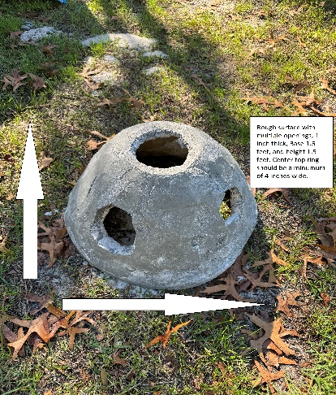
Dimensions
1.5 ft wide
1.5 ft tall
Marine grade concrete should be approximately 1 inch thick.
Surface of oyster dome
Variety of openings (size of opens can vary)
Two of the opens need to be directly across from each other centered. These opens will be used to carry the oyster reef domes.
Surface texture should be rough to allow oyster spat to attach to the surface.
Opening on the top of the reef dome should be a minimum of 4 inches.
Drying time
Allow it to dry for at least 24 hours before moving
Use the two centered opens to remove the oyster reef dome from the sand cast.
Set aside to dry for another 24 hours
Oyster cultch
Cultch much be sun baked for three months
Attach half oyster shells to surface of the oyster reef dome with concrete. (back butter)
Transportation
If feasible EMC staff will pick up oysters reefs balls from schools and deliver them to the EMC. (Minimum of 5 oyster reef domes for pickup)
If less than 5 oyster reef domes are made the schools will transport the oyster domes on the school bus during their visit.

Setup
Setup oyster reef domes base plate with 2-inch PVC.
Add play sand to the base plate that is wet but not too wet.
Use template form 1 to create reef dome sand cast
Pat sand down, spray more water if needed, and add more sand to low spots.
It doesn’t have to be perfect. Close enough is good enough.
Remove form template form 1.
Use template form 2. This form will help you gauge the thickness of your concrete. Doesn’t have to be perfect. Close is close enough.
Concrete (marine grade safe)
Use a 2 to 1 ratio of Portland cement to sand mix
2parts Portland cement
1 part sand
1 part water
Mix together
Texture should stick to margin hand trowel. Not to dry, not to wet
Create a 1-inch base around the oyster reef dome.
Create a 1-inch top around the center PVC pole.
Use the concrete trowel to hold concrete as the margin trowel adds cement to create a vertical wall layer in between the bottom and top ring.
After the entire surface has close to 1-inch-thick concrete, let it set up for at least 10 minutes before making your opening.
Create openings
Using the margin trowel cut out holes around the oyster reef dome.
Two holes should be centered and directly across from each other. These holes will be used to carry the dry oyster reef domes.
Try to stay at least two inches away from the base and top ring opening.

Oyster reef dome diagram
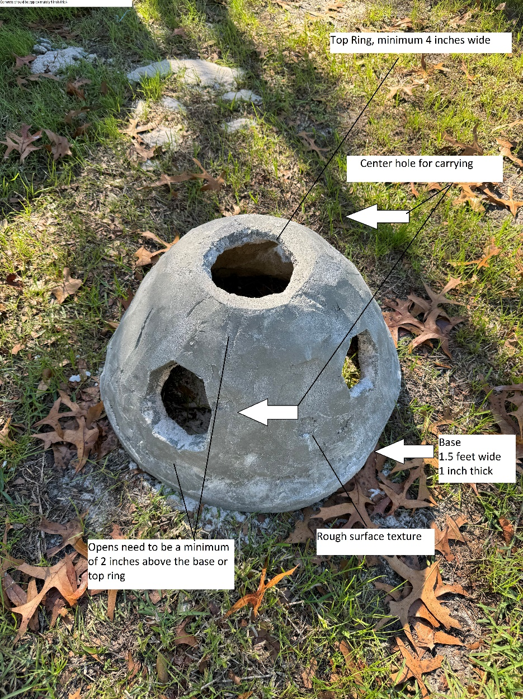
Oyster reef dome (or ball)
Top ring
Base
Centered carrying holes
Varies openings
Rough surface texture
Oyster cultch
Back butter
Margin trowel
Hand trowel
Base plate
Center PVC poles (2 inches)
Sand cast
Spray bottle
Form template 1 and 2
Mixer
2:1:1 ratio

