G. Proposed Activities
1. Removal of invasive plant species
2. Planting of native plant species
3. Installing oyster reef domes
To access the property, we will be using our two pontoon boats to transport material, equipment, and students to carry out these three activities.
Durney key will be divided into 5 zones. We will only be working on the north and east end of each of these sections along the shoreline. Student volunteers from various Pasco County high schools along with the Secondary Environmental Resource Teacher from the Energy and Marine Center will identify, mark, map, and remove invasive plants and plant native vegetation from within each zone over a 5-year period. We will also be installing oyster reef domes along the North and East ends of the island.
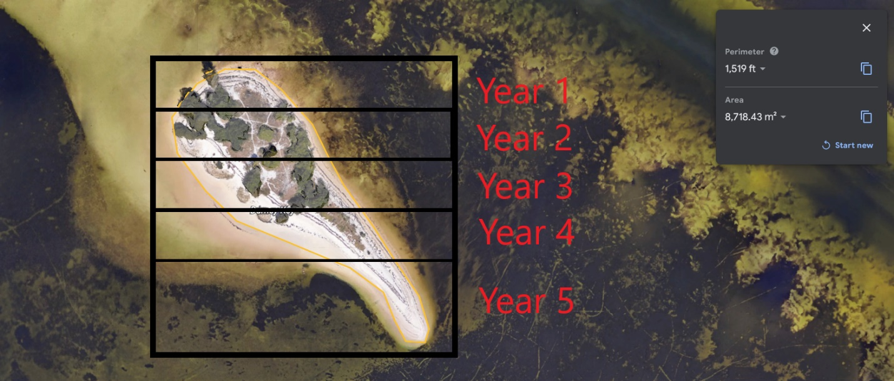
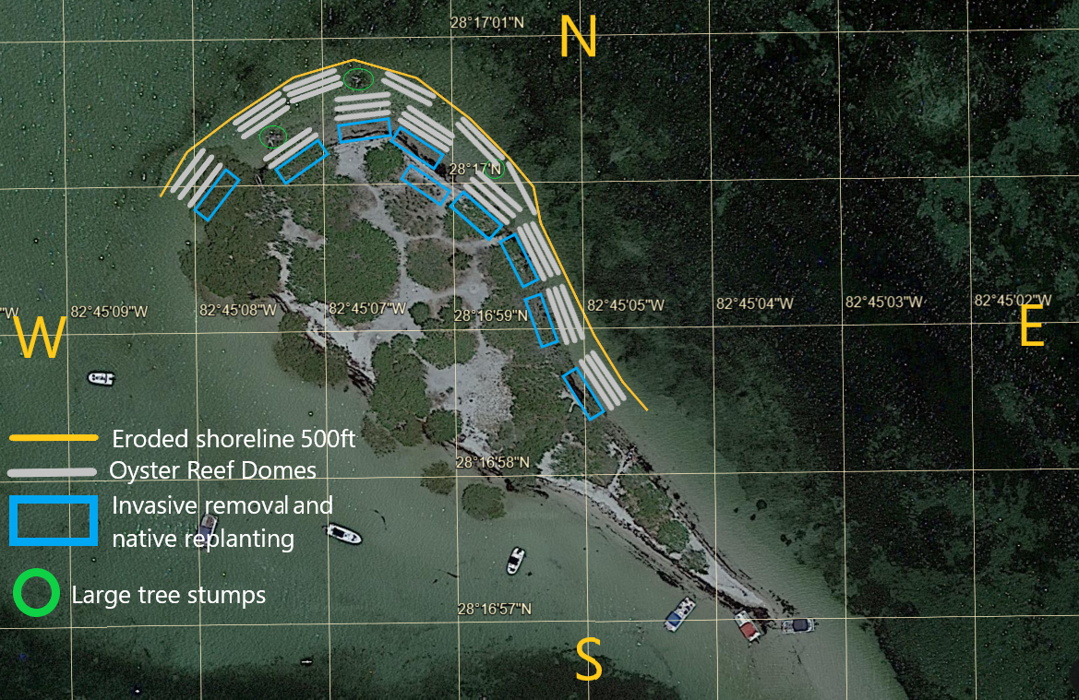

- Removal of invasive plant species
List of invasive plants that will be identified, marked, mapped, and removed are as follows.

Brazilian pepper (Schinus terebinthifolia)
Australian pine (Casuarina equisetifloria)
Norfolk pine (Araucaria heterophylla)
Lead tree (Leucaena leucocephala)

Our goal is to do quarterly identification of invasive species on Durney Key, volunteers/students from varies Pasco County high schools will mark and map invasive plants for removal. We will transport students and material on our two pontoon boats to Durney Key. Volunteers will be given identification guides of common invasive species found on Durney Key. We will be using the University of Florida, Institute of Food and Agricultural Sciences, Invasive Plant Management Plan for each species we tag for removal.
We will be using the cut stump treatment method to remove invasive species. After using hand saws and loppers the “Stump treatments are applied after cutting and removing large trees or brush. The concentrated or diluted herbicide is sprayed or painted onto the cut surface of the stump immediately after cutting”. We do not want to manually remove the stumps due to concerns this would cause extensive soil disturbance and could lead to further soil erosion.
Through our partnerships with Werner-Boyce Salt Spring State Park rangers will assist in the stump treatment spraying of these invasive species when available. When not available we will continuously monitor and cut regrowth of invasives. Durney key will be divided into five zones. After identification/tagging, removal and spraying in each zone, we will restore these areas with native plants, spartina grass and mangroves from our cultivation tanks. Each zone will be evaluated on which species should be placed where for our replanting efforts.

Planting of Native Species
Students collected propagules in October 2023 that had floated up with the seaweed wrack onto our shoreline. Red and black mangroves along with Spartina are currently being grown in raised cultivation gardens at the Energy and Marine Center (EMC). Our objective is to use mangroves and spartina grass to restore shoreline sections along Durney Key after invasive species are removed. “Planting Time: Late winter and early spring (and beginning of rainy season in Florida). Plant Material: Potted plants or bare root stock from vigorous, uncrowded stands - 5 to 10 stems per transplant. Spacing: Place plants 12 to 24 inches apart depending on severity of site. Depth: Plant soil and root mass 6 to 8 inches or deeper in moist soil” (USDA-NRCS 1996) We will follow USDA-NRCS guidelines for planting spartina, and we will be using the BEST PRACTICE GUIDELINES ON RESTORATION OF MANGROVES (Amarasinghe, 2007) for planting red and black mangroves.
Spartina cultivation garden Red and black cultivation gardens
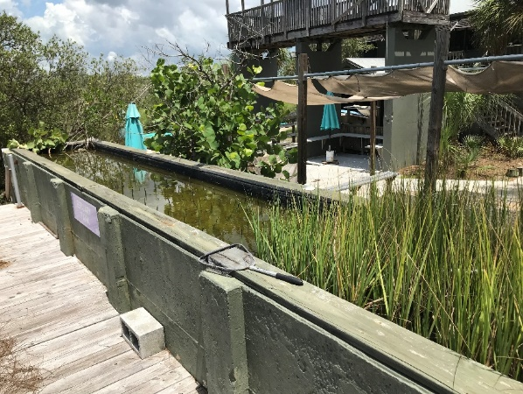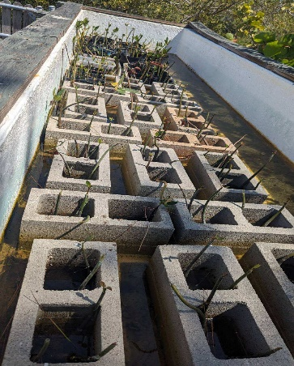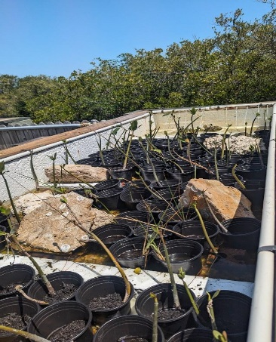
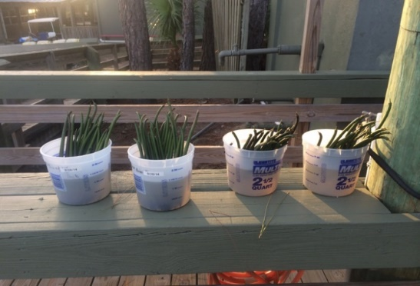
Following the natural zonation. Rhizophora (red mangroves) that can tolerate high inundation and deep mud, should be planted close to water Avicennia (black mangroves) should be planted in the areas close to the shoreline.
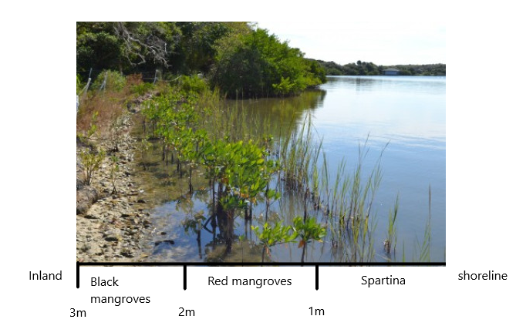

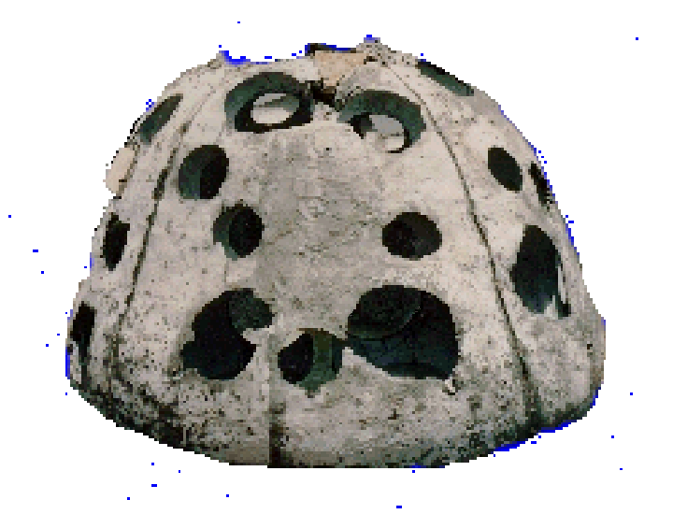

Installing oyster reef domes
A breakwater will be installed using oyster reef domes. A permanent wave attenuation is required to maintain the shoreline vegetation. The oyster reef domes will not extend more than 10 feet waterward from the original eroded shoreline MHWL or OHWL and top height of no more than mean or ordinary high water elevation. The oyster reef dome breakwater is composed predominantly of marine grade concrete and natural oyster shell cultch that we will collect from local restaurants and sun bake for three months before installing them. The substrate that we will be placing the oyster reef domes on is sandy/rocky bottoms and there are no seagrass beds within three feet in any direction of where the oyster reef domes will be placed. The oyster reef domes will be placed in rows of 2-3, no longer than 75 linear feet long, and have openings of at least 5 feet in width to allow the flow of water, fish, aquatic wildlife, and kayakers. Please see attached document “Oyster Reef Domes Rubric” for description of oyster reef domes. Replanting of native species will start along the current eroded average mean high tide line (shoreline). Spartina grasses will be planted along the first meter of shoreline. Red mangroves will be planted behind the spartina at a distance of 1-2 meters from the shoreline. Lastly, black mangroves will be planted at a distance of 2-3 meter inland from the shoreline. Oyster reef balls will be installed in year 1-3 zones on Durney Key. This is only needed on the North and East end of Durney Key where wave/boat wake erosion is affecting the key. We plan to use all 500 linear feet of the Environment Resource Permit (ERP) exemption and is indicated by the yellow boundary line below.

Oyster reef domes will be placed no more than 10ft from the original shoreline that has been eroded. The yellow boundary is the original shoreline plus 10ft. We used three large tree stumps to show where the island shoreline used to be they are circled in green in the map above. The gray areas indicate where we would like to place our oyster reef domes. These areas show some oyster growth on rocks and are deep enough, so the oyster reefs top height is no more than mean or ordinary high water elevation. 10 feet for the current MHWL or OHWL along the eroded shoreline would not meet the top height requirements.

