Durney key invasive plant survey and removal

Our goal is to do quarterly identification of invasive species on Durney Key, volunteers/students from varies Pasco County high schools will mark and map invasive plants for removal. volunteers will be given identification guides of common invasive species found on Durney Key. We will be using the University of Florida, Institute of Food and Agricultural Sciences, Invasive Plant Management Plan for each species we tag for removal. (Langeland, 2015)
We will be using the cut stump treatment method to remove invasive species. “Stump treatments are applied after cutting and removing large trees or brush. The concentrated or diluted herbicide is sprayed or painted onto the cut surface of the stump immediately after cutting”. (Langeland, 2015) We don’t want to manually remove the stumps due to concerns this would cause extensive soil disturbance and could lead to further soil erosion.
Through our partnerships with Werner-Boyce Salt Spring State Park they will assist in removal and spraying of these invasive species. Durney key will be divided into five zones. After identification/tagging, removal and spraying in each zone, we will restore these areas with native plants, spartina grass and mangroves from our cultivation tanks. Each zone will be evaluated on which species should be placed where for our replanting efforts
The island has had a large population of invasive species for most of its history and it will be challenging to remove decades of seed stock and prevent additional seeds from recruiting to this area from wind, tides, and animal dispersal. Efforts will be made to remove them as replanting of natives will take time to out compete them. “It often takes several years for plantings to become thoroughly established. Extra water, nutrients, and protection from fire and pests may be necessary for a while”. (Langeland, 2015) We will continue to monitor each zone and remove and treat invasives as they return.

List of invasive plants that will be identified, marked, mapped, and removed are as follows.
- Brazilian pepper (Schinus terebinthifolia)
- Australian pine (Casuarina equisetifloria)
- Norfolk pine (Araucaria heterophylla)
- Lead tree (Leucaena leucocephala)

List of native plants that will be replanted will include
- Spartina (Spartina alternaflora)
- Red mangroves (Rhizophora mangle)
- Black mangroves (Avicennia germinan)

Mangrove count survey
Mangrove line intercept mapping Systematically mapping the three mangrove species that occur in our estuary and on Durney key. Using the Line Intercept method (LI), will use a 10m long transect line to identify species and horizontal coverage along the shoreline in each of our five focal zones (see map attached). Stratified random sampling points will be assigned along the transect line to determine depth of mangroves and species as elevation increases from shoreline to upland. Due to the overlapping of branches of the same species and different species and the difficulty in determining the center of the multi-stem mangroves we have chosen the LI method, “this method is primarily designed to sample plant species with dense crowns or large basal areas.”

Target Species Cultivation

Mangrove and Spartina cultivation and planting

The Energy and Marine Center (EMC) is currently cultivating mangroves and spartina grass in a raised cultivation garden. Our objective is to use mangroves and spartina grass to restore shoreline sections along Durney Key after invasive species are removed. EMC staff and students will evaluate the replanting zone on Durney Key to determine the best areas to replant “Planting Time: Late winter and early spring (and beginning of rainy season in Florida). Plant Material: Potted plants or bare root stock from vigorous, uncrowded stands - 5 to 10 stems per transplant. Spacing: Place plants 12 to 24 inches apart depending on severity of site. Depth: Plant soil and root mass 6 to 8 inches or deeper in moist soil” (USDA-NRCS 1996) We will follow USDA-NRCS guidelines for planting spartina, and we will be using the BEST PRACTICE GUIDELINES ON RESTORATION OF MANGROVES (Amarasinghe, 2007) for planting red and black mangroves.
Mangrove and Spartina transplant success rate. It may take several attempts for the replanting effort to be effective. It is likely some plants will not survive due to improper handling and planting as we will be working with students. Staff and Volunteers will receive training to educate them on proper planting procedures.
The island has a heavy human footprint. We will attempt to inform and educate the public of our efforts through signage, but it is highly likely some of our plantings may have people walking through them, stepping on them, dragging kayaks across them. It is also possible that some people might not appreciate our efforts and may move the oyster reef balls and/or remove our transplanted plants.
Tropical storms and hurricanes could cause delays in project implementation and activities as well as physically impacting the island itself (storm surge/erosion).
The island has had a large population of invasive species for most of its history and it will be challenging to remove decades of seed stock and prevent additional seeds from recruiting to this area from wind, tides, and animal dispersal. Efforts will be made to remove them as replanting of natives will take time to out compete them.
Soil deposition may occur behind the breakwater of the oyster reef balls and while some is expected it might bury some of our plants. Adjustments will be made to replant in areas impacted by significant soil deposition.
The proposed projects are exempt from permitting. Department of Environmental Protection has granted us permission to adopt the spoil island and they will act as a co-manager of the restoration projects.

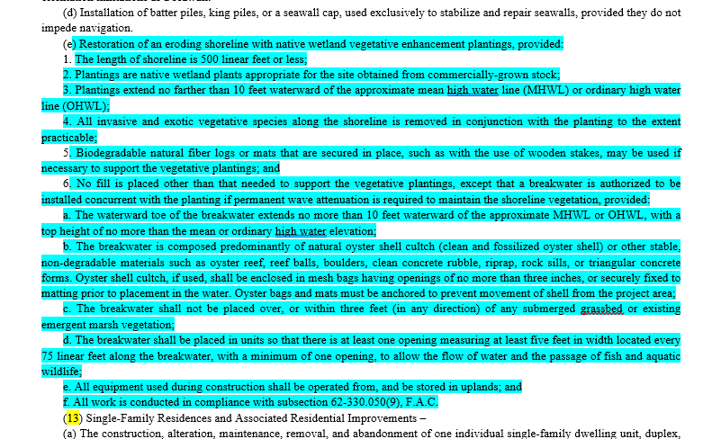
Follow the natural zonation. Rhizophora (red mangroves) that can tolerate high inundation and deep mud, should be planted close to water Avicennia (black mangroves) and Lumnitzera should be planted in the areas close to hinterland. (Amarasinghe, et al. 2007).
Embed nearly 15 cm of the propagule in a hole made in the mud using a wooden stick. To avoid crab predation paint hypocotyls yellow or place them inside a piece of bamboo (to cover the part easily eaten by crabs). Planting distance – 1.5m x 1.5m Holes should be made using an auger/spade during low tide and seedlings should be placed after cutting the polythene bag open. Planting distance - 2m x 2m (need 2500 seedlings/ha). (Amarasinghe, et al. 2007).
Natural zonation of mangrove plants in an inter-tidal area. All mangrove plant species do not have the same ability to tolerate soil salinity, nutrient, wave energy and flooding (anaerobic) conditions that vary within, as well as among, mangrove areas. Depending on the soil, hydrological, extent to which the area is protected from waves with high energy and nutrient conditions of the inter-tidal area, mangrove species occupy different localities in an inter-tidal area, forming zones of vegetation. Each zone is composed of either one or a few species of mangroves that can tolerate its environmental conditions. Knowledge on mangrove zonation therefore is essential to determine suitable candidate species for planting. Although natural zonation depends also on dispersal of propagules from water towards land which is determined in turn on the size and weight of the propagule and the strength of the tidal current, it is not a critical factor in that affect success of cultivation of mangroves as propagules are transported to the site of cultivation. (Amarasinghe, et al. 2007)
Mangrove species mentioned in the Coastal Protection by Planted Mangrove Forest during Typhoon Mangkhut study are the same genus as our mangroves found in Florida and inhabit similar coastal habitats. Although they are not the same species, the requirements necessary for both are the same. “This paper presents field evidence that demonstrates that planted mangroves can effectively enhance coastal resilience to tropical storms. The results support nature-based coastal stabilization policies and encourage the usage of planting mangroves in coastal restoration and conservation projects”. (Zhang X, Lin P, Chen X., 2022)
The long-term risks mirror those shared above with some added uncertainties. Primally staff and volunteer turnover. To mitigate this impact, consistent and clear methodology and procedures, in addition to training will be provided as a requirement for project participation.
Because this involves a near shore coastal environment subject to tides, tropical weather events, wind and wave action, as well as human interaction, consistent monitoring and timely response to changes will be a priority. The addition of oyster reef balls will assist to buffer the impacts of those events on the transplanted species and island overall.

