Blue Carbon

Measuring the amount of organic carbon in our soils around mangroves. Use as a comparison between other marine/aquatic habitats and upland habitats.
Material
Augers. Gouge Auger for wet/soft soil, Bucket auger for course/compacted soil, and post hole digger for dry sandy soil.
Measuring tape – meter stick, ruler or tape measure
Ziploc baggies- for soil collection
Scale – triple balance beam or digital scale
Crucible- for burning off organic carbon from dry soil sample.
Torch
Oven or drying rack – drying wet soil
Marker – mark Ziploc bags with soil depth
Mortar and Pestle – grind up dry chunky soil
Vernier soil moisture probe
Goggles
Hot glove
Tongue depressor
Vocabulary
Auger
Dripline
Mortar
Pestle
Crucible
Organic and inorganic carbon
Blue carbon

Directions
During low tide, collect soil samples from the mangroves along the shoreline. Using the gouge auger to collect a soil sample to a depth of 20 cm. Soil sample should be taken near the furthest edge of the canopy dripline. Avoid areas that are rocky or has lots of fibrous roots near the soil surface.
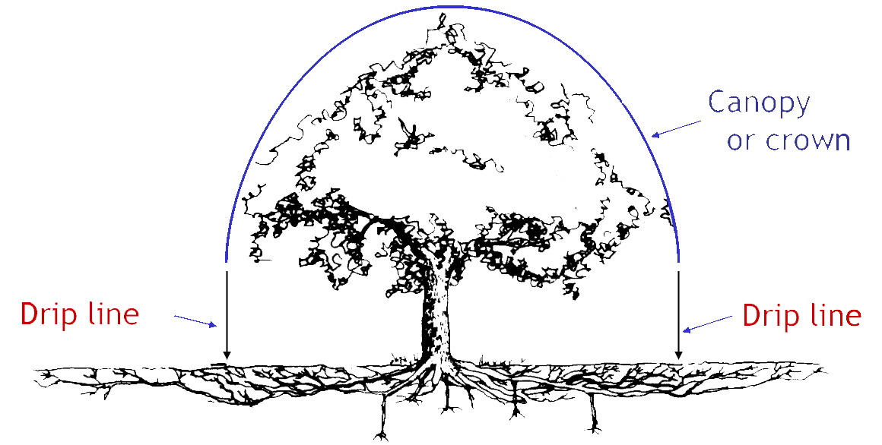
1. Measure the distance from the trunk of the tree to the drip line where you will be collecting your first soil sample. Typical this will be done from the tallest mangrove and presumably the oldest mangrove. There maybe several other smaller mangroves under this drip line.
2. Using the gouge auger mark where 20, 15, 10 and 5 cm depths are on the auger.
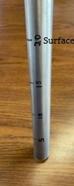
3. Push down and rotate the auger to a depth of 20cm.
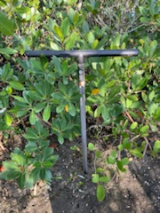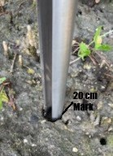
4. Twist and pull auger out.
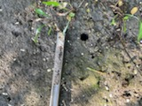
5. Using the open face of the auger check and calculate if there was any soil compaction. Measure the length of the sample recovery and the length of the sample core hole with a tape measure. If the sample core hole is longer/deeper than the length of the recovered sample in the auger than we had soil compaction.
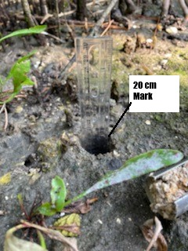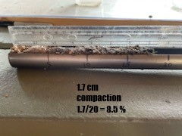
The compaction correction factor is calculated by dividing the length of sample recovery by the length of core penetration. During sample processing the corrected sample length is determined by multiplying the desired depth interval by the compaction correction factor.
FOR EXAMPLE• A sample is recovered that is 18.3 cm long• But the depth reached by the corer was 20 cm• This will give you soil compaction of 1.7 cm, a compaction correction factor can be found by dividing the length of the sample by the corer depth (18.7 cm / 20 cm = 0.92).• If we then wanted to obtain a sample that represents the top 5 cm of the soil we would need to multiply the depth interval (5 cm) by the compaction correction factor (5 x 0.92) giving a new sample recovery measurement of 4.6 cm.

6. Starting at the bottom of the soil auger remove the first 5cm (if soil is compacted use the measurement from the example above) of soil and place in a Ziploc bag. Label this bag 15-20cm depth.
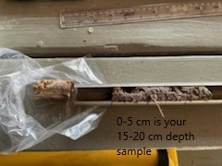
7. repeat step above every 5cm. label Ziploc bags 10-15cm, 5-10cm and 0-5cm.
8. weigh wet samples and record their initial weight
9. Dry samples on drying rack. Use soil moisture probe.
10. reweigh dry sample to calculate water weight.
11. Burn dry sample in crucible with torch. Use a large table to collect any soil or organic matter that flies out of the crucible.
12. Use mortar and pestle to grind up into a powdery consistence.
13. Burn off all organic matter and reweigh burn sample to calculate the percentage of organic matter vs. inorganic soil.
Soil sample depth | Wet weight | Dry weight | Burn weight | % of carbon
0-5 cm
5-10 cm
10-15 cm
15-20 cm

