Guided Kayaking Tour Instructions

Salt Spring Estuary
Ask student if they know what an estuary is? Estuaries are Semi-enclosed, look how the mangrove trees almost entirely encircle us. We have brackish water. Estuaries are where freshwater and saltwater meet and mix to make brackish water. Estuaries are known as the nursery of the sea. Do you think we have big fish or little fish here? We have both but it is a great place for small baby fish to start. Why do you think it is a great place for baby fish? Talk about the MOMS (Mangrove, Oyster, Marshes and Seagrasses), they provide shelter, food, clean our water, and make great hiding spots from bigger fish that might want to eat them.
Mangroves
How many different species of mangroves do you think we have in the estuary? 3, Red, Black and White Mangroves. There are a couple different ways to tell them apart. 1. Leaves 2. Their roots. 3. Propagules. What do you think would happen if we took this brackish water and poured it on your plants and grass at home? They would die. How do the mangrove and other plants survive here? They can filter out the salt or sweat it out on to the leaf and their roots act as snorkels. Have you ever licked a black mangrove leaf? Here is your chance!
Parks Surrounding the EMC
The Salt Spring Estuary is surrounded by a county park to our South (Brasher Park) and a state park (Werner-Boyce Salt Spring State Park) to our North and East. Ask if they know which way is West. Use the EMC building as your compass rose. Ask if they know the name of the salt body of water on the West side of Florida and the East side. Pasco County is on the West side of Florida and our county shoreline is along the Gulf of Mexico. The East side of Florida borders the Atlantic Ocean. Ask them if they think Florida has more coastline than from Georgia to Maine. Florida has more than 1600 miles of coastline. From Georgia to Maine, it is only 1500 miles.
Oysters
Do you think these are the same oysters you would get if you ordered them at a restaurant? Yes, our oysters are just a little smaller due to our tides here in the estuary. Do you think these oysters produce pearls? Yes, all oysters produce pearls, but ours are smaller and not valuable. Do you think oysters are important to other animals and why? Yes, they are a keystone species which means other animals depend on them to filter the water, provide them food, they create homes, and shelter for many other animals. What do you think would happen if oysters disappeared from the estuary here? Lots of our animals would suffer and might disappear too.
Birds
Ask if they have seen any birds while kayaking. Have them use the bird ID charts to try an identify at least one bird they have seen but do not know what its name is. Why do you think so many different types of birds like to come to the estuary? Estuaries are shallow and have lots of small fish and invertebrates for wading birds to eat. The Mangroves slow down the wind and waves and make estuaries very calm and great places to eat, roost, and nest.
Sea grasses
What’s up with all the grass that is growing underwater? There are four sea grasses that are common along the Gulf Coast. Two of these grasses grow in estuaries, Shoal and widgeon grasses. The other two grasses grow in saltier water just outside the estuary and are named after the animals that eat them, manatee, and turtle grass. Do you think these sea grasses are important? You bet they are! Sea grasses make oxygen for fish, they clean the water, they are hiding areas for smaller fish, they provide food and prevent erosion.
Fishing
What kind of fish do you think those fishermen are fishing for? Estuaries are a great place to catch fish. Some of the most popular fish are Red and black drums, Snook, Sheepshead, Sea Trout, and Mangrove snappers. What about all these fish that are jumping out of the water? What are they and why are they jumping? That would be our mullet. So, how do you catch mullet? You have to use a cast net to catch mullet, they eat algae, and they don’t bite on hook and line. Why do you think they jump out of the water? Maybe they are being chased by bigger fish, maybe they are playing, showing off, breathing air, or maybe it is for another reason. Scientist aren’t exactly sure why but it could be for all of these reasons. Maybe one day you will become a scientist and find out why they jump!

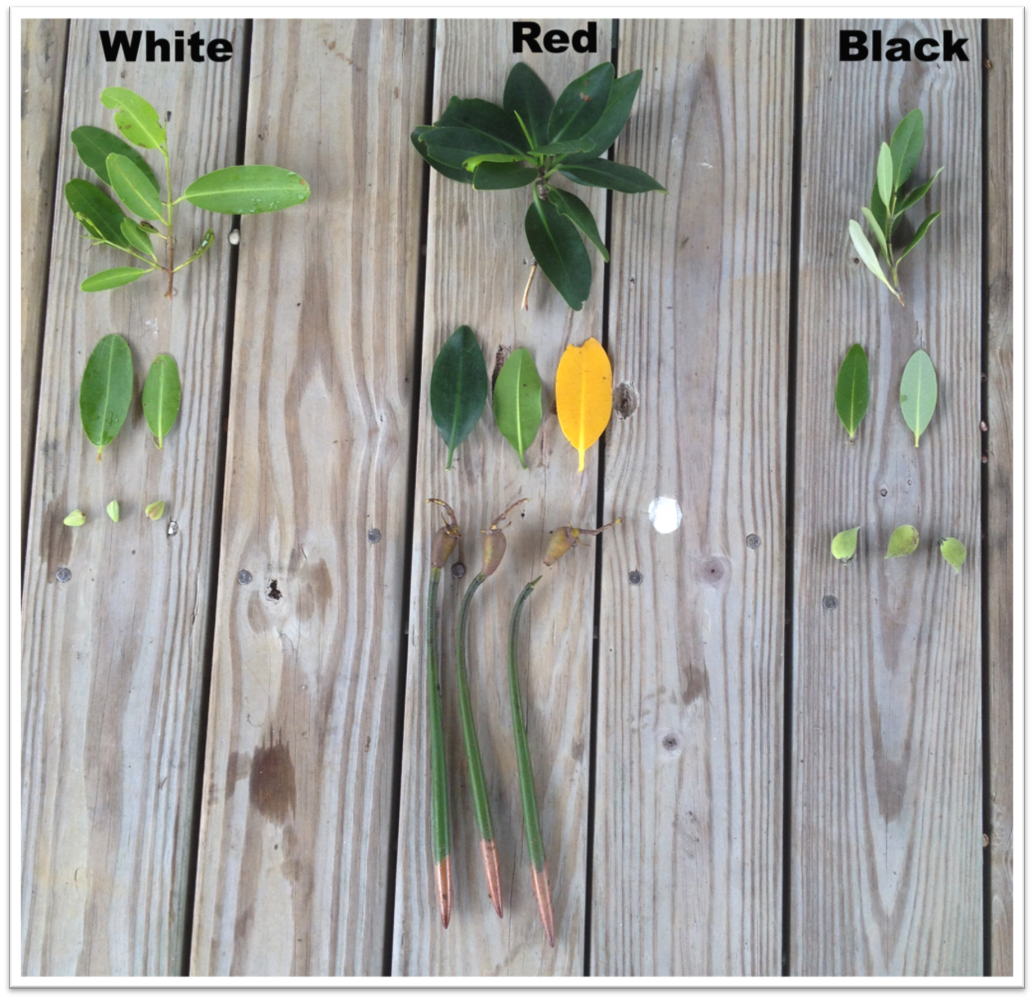

All the Green area around the Energy & Marine Center is protected county and state parks.

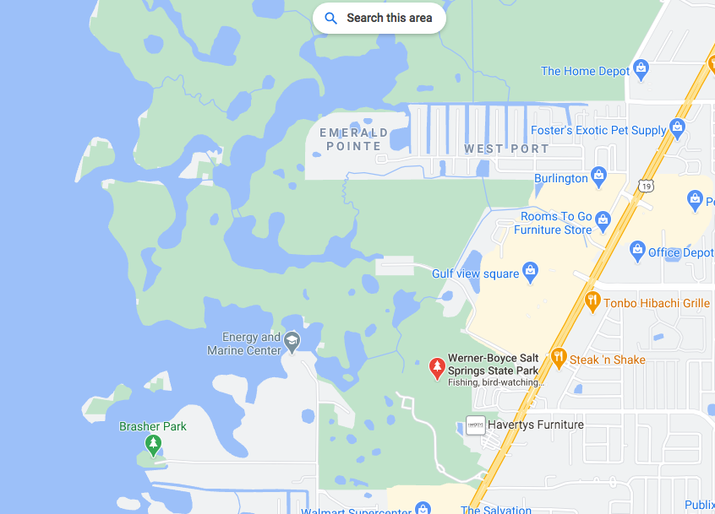

Species Identify Guide

Florida's Seagrasses
Although approximately 52 species of seagrasses exist worldwide, only seven species are found in Florida's marine waters. Six of these are widespread in Florida and extend beyond its borders.

Turtle grass  Drawing: FWC | - Turtle grass (Thalassia testudinum) the largest of the Florida seagrasses, has deeper root structures than any of the other seagrasses. It has large ribbon-like leaves that are 4-12 mm wide and 10-35 mm cm long. This seagrass is temperature limited and does not occur along the northeast Florida coast, but it forms extensive beds in Florida Bay.
Shoal grass  Drawing: FWC | - Shoal grass (Halodule wrightii) is an early colonizer of vegetated areas and usually grows in water too shallow for other species except widgeon grass. It is most common in inlets along the east coast.
Manatee grass  Drawing: FWC | - Manatee grass (Syringodium filiforme) is easily recognizable because its leaves are cylindrical instead of ribbon-like and flat like many other seagrass species. The thin leaves are up to half a meter long. The northern limit of manatee-grass is the Indian River, near Cape Canaveral. Manatee grass is usually found in mixed seagrass beds or small, dense monospecific patches.
Widgeon grass  Drawing: FWC | - Widgeon grass (Ruppia maritima) grows in both fresh and salt water and is widely distributed throughout Florida's estuaries in less saline areas, particularly in inlets along the Florida east coast.

