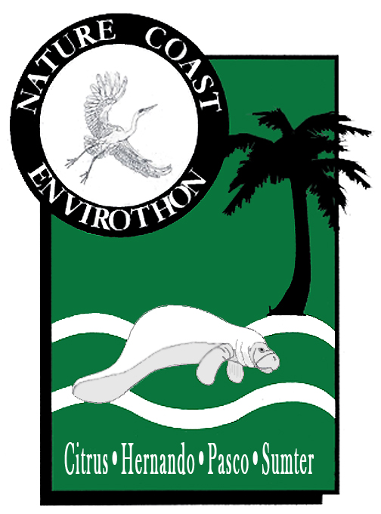

To: | High School Teachers, Advisors and Contacts for Citrus, Hernando, Pasco, and Sumter High School Students
From: | Nature Coast Envirothon Steering Committee
Date: | November 16, 2018
Subject: | 2019 Nature Coast Envirothon Information

The 2019 Nature Coast Envirothon will be held on February 19th, 2019, at Crews Lake Park in Pasco County. Please use the online link to register your teams. Each team must submit a separate registration form. The registration deadline is Friday, January 25th, 2019.

Online Registration form: https://docs.google.com/forms/d/e/1FAIpQLSf2bzPLeHdUppKBlUswtYDw1Vv-Yy4imy_wgS-Xj1-tze8zTQ/viewform

The study materials are available online at http://connectplus.pasco.k12.fl.us/do/eec/?page_id=10
All materials will be updated and current as of December 3rd, 2018. Study material can also be found at https://www.envirothon.org/the-competition/current-competition All test questions will be based on the information contained in the study material. Tests are composed of multiple-choice questions. Many of the questions will require hands-on activities to determine the correct answer.

The Envirothon is open to high school students in grades 9-12. They may register as a high school team, representing any school (public or private) within the 4-county area. Home school, Scout groups, 4-H Clubs, church youth groups, or any other organized group may register a team provided the team members are all high school students and reside in the same county. Each school/group may register multiple teams. Each team must have five members. The team must have an adult advisor; one adult may be an advisor for multiple teams. Each school will only be allowed to send a maximum of 5 teams. A pre-test can be found on the website that may be used to determine school teams.

Lunches will be provided to all students and sponsors. Please inform us of any student food allergies or if a student requests a vegetarian meal.

The highest scoring team from each County and the overall winner will be eligible to compete at the State Envirothon competition in April. The State Champion will be eligible to compete at the National Level.

If you have any questions or need further information, please e-mail your questions to the following address: Josh McCart Jmccart@pasco.k12.fl.us
Thank you,
The Nature Coast Envirothon Steering Committee

