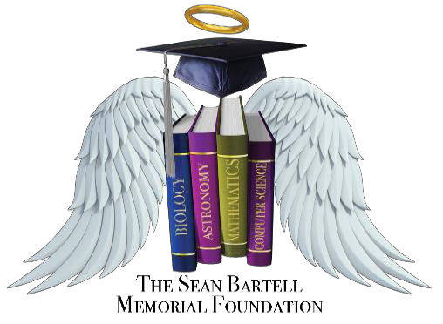

Applicant: Address:

Email:

Phone number:

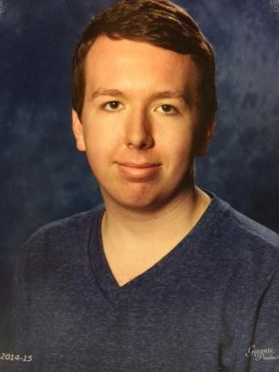Zephyrhills High School
Grant Application

Un-weighted GPA (Min. 3.5): School Representative verification:

Where will you be attending college/University?

The applicant is responsible for submitting all materials to April Simons by April 28, 2021. Incomplete applications will not be evaluated. This application becomes complete and valid only when all of the following materials have been received:

This application completed

School representative must verify applicant's Un-weighted GPA written above.
Two letters of recommendation are required. One from a teacher and one from a peer. A copy of documented and confirmed 60 volunteer hours. Copy must be signed by a
school representative.

Essay detailing your plans as they relate to your educational and career objectives and long-term goals. Please include how and when any unusual family or personal circumstances have affected your achievement in school, work experience, or your participation in school and community activities.

If you have any questions, please contact April Simons in Room 724 or at asimons@pasco.k12.fl.us

www.seanbartell.org Email: spbfoundation@hotmail.com Facebook: Sean Bartell Memorial Foundation

