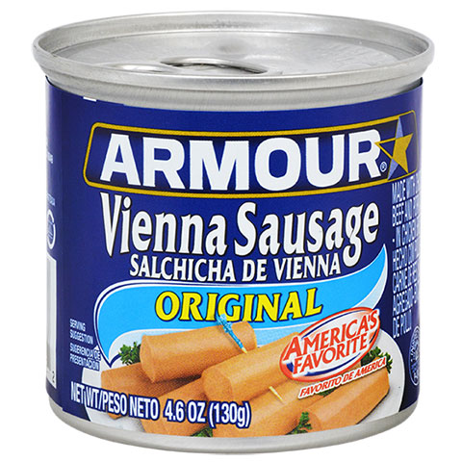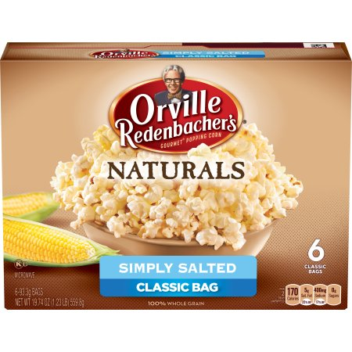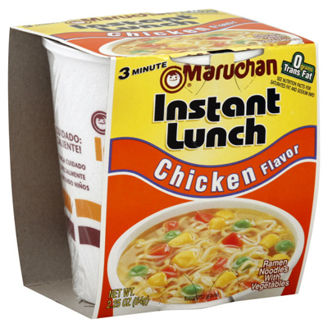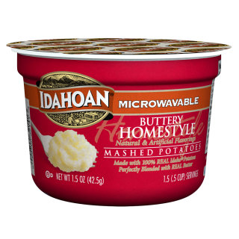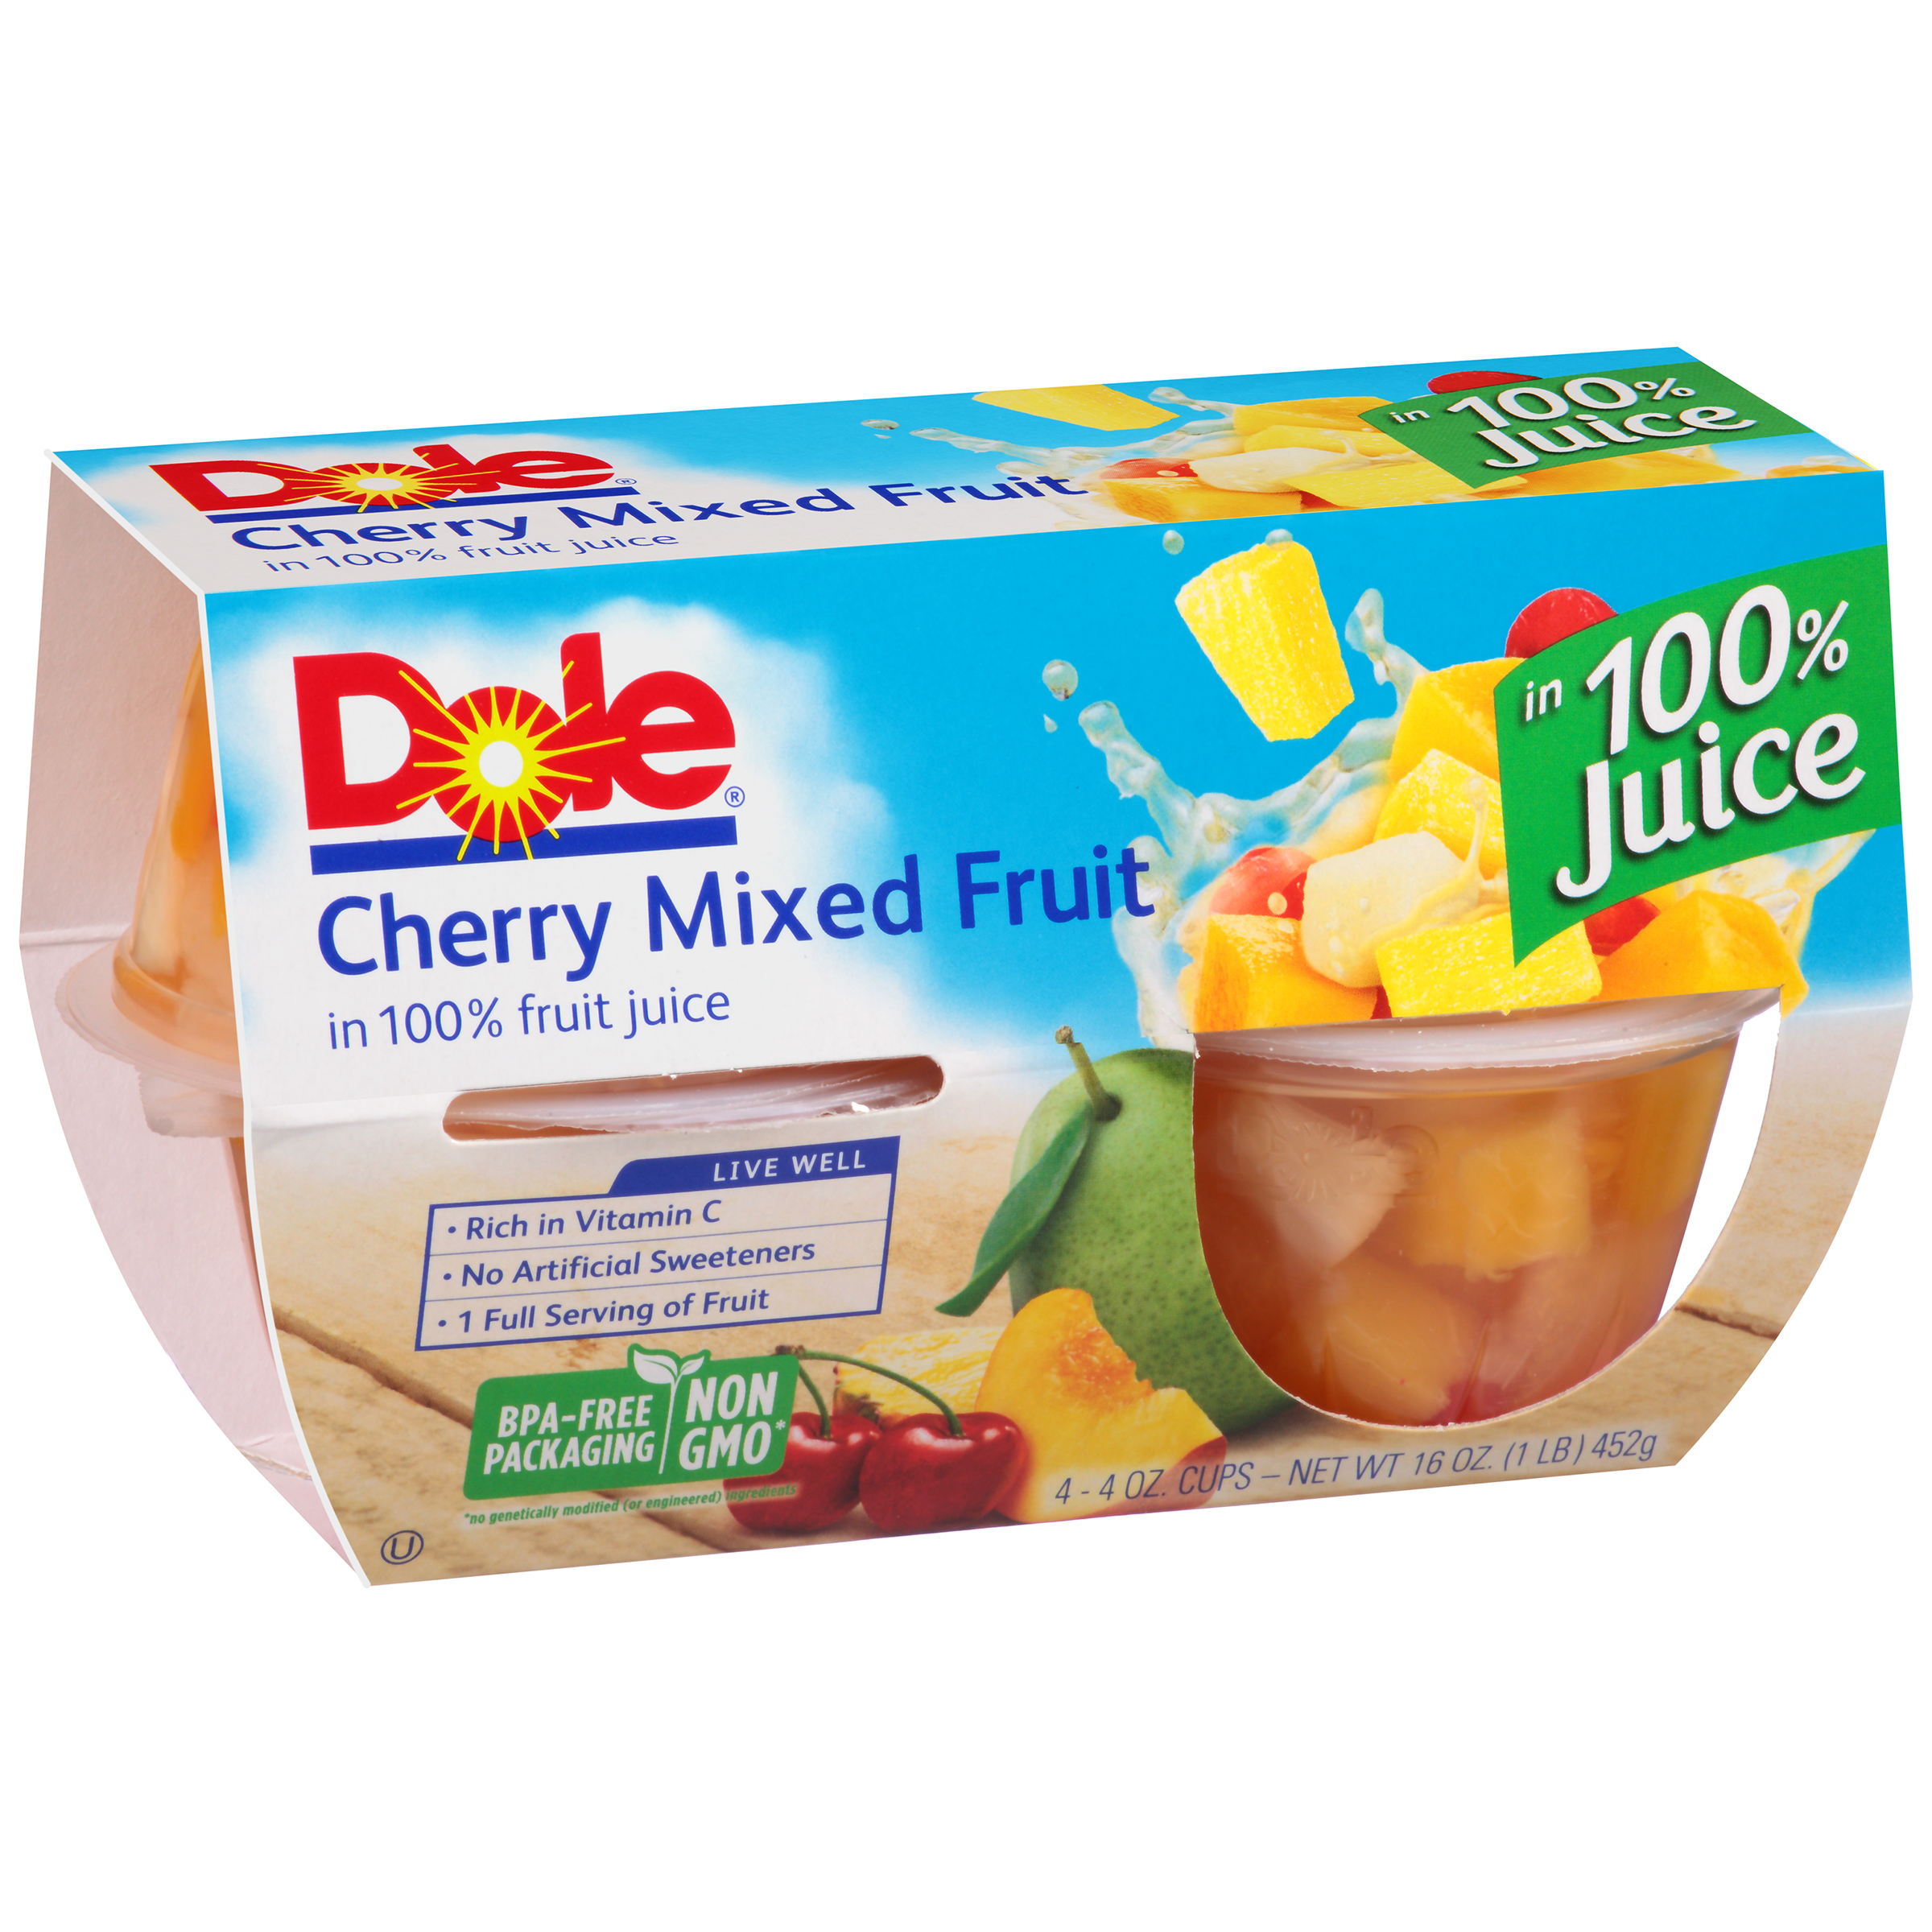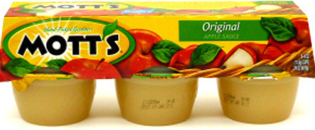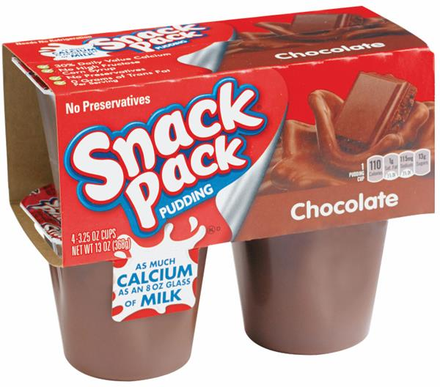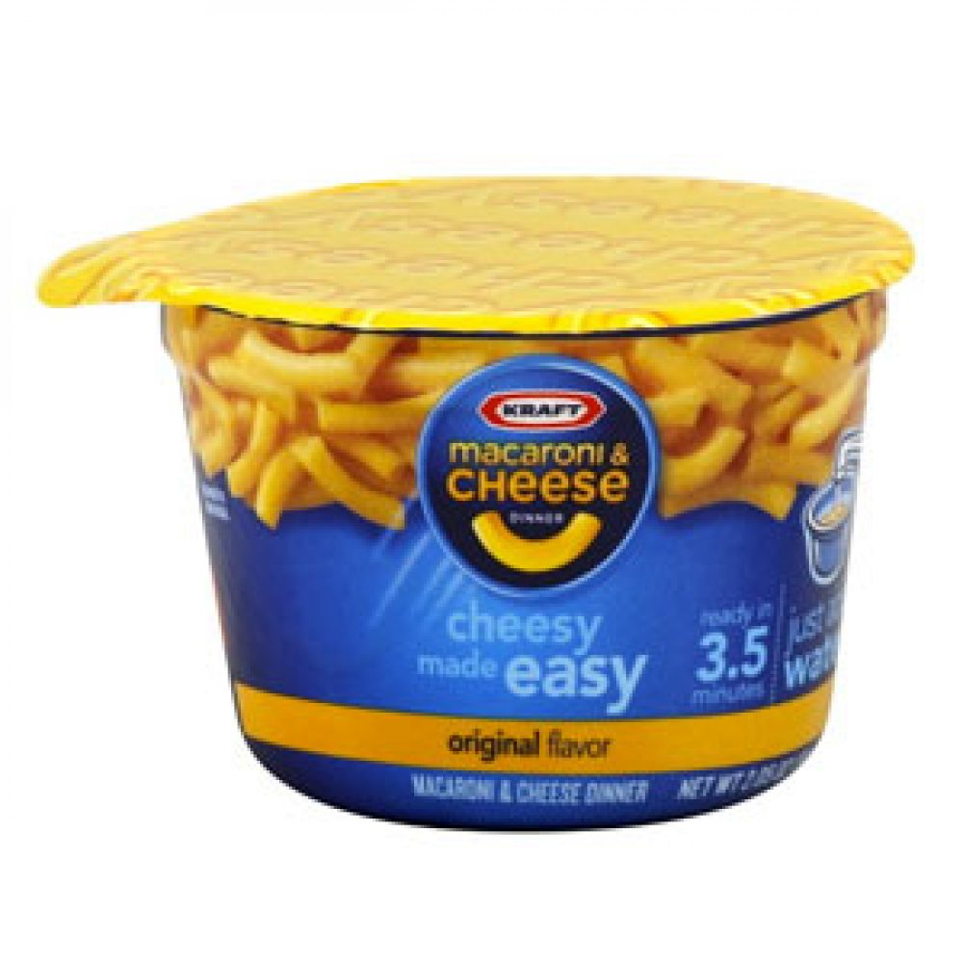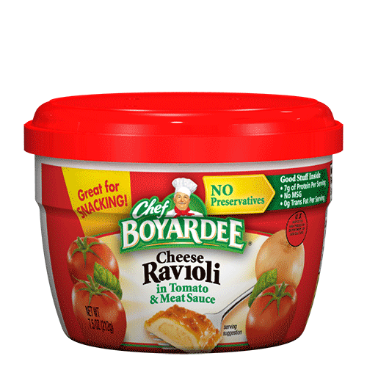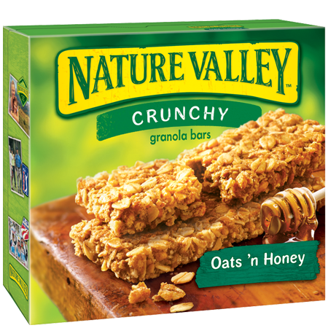

* Graham Crackers
* Animal Crackers
* Microwave Popcorn
* Whole Grain Granola Bars
* Individual Cereal Boxes
* Canned Ravioli
* Spaghetti & Meatballs
* Beefaroni
* Lasagna
* Canned Fruit
* Fruit Cups
* Pudding Cups
* Applesauce Cups
* Raisins
* Juice Boxes
* Pop Tarts
* Oatmeal Packs
* Ramen Noodles
* Instant Mashed Potato Cups
* Mac & Cheese Cups
* Vienna Sausages
* Slim Jims
* Chicken Noodle Soup
* Trail Mix
* Cheese Crackers
* Peanut Butter Crackers

4 Items= 1 hour

7 Items= 2 hours

**BackPack Program Most Needed Items**

(Pop-top items or Microwave cups preferred)