[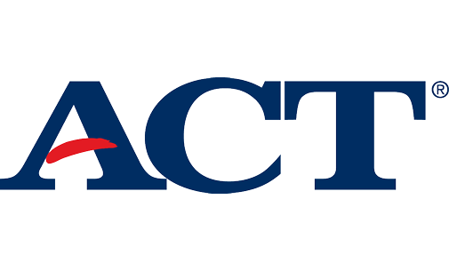](https://www.act.org/content/act/en/products-and-services/the-act.html)[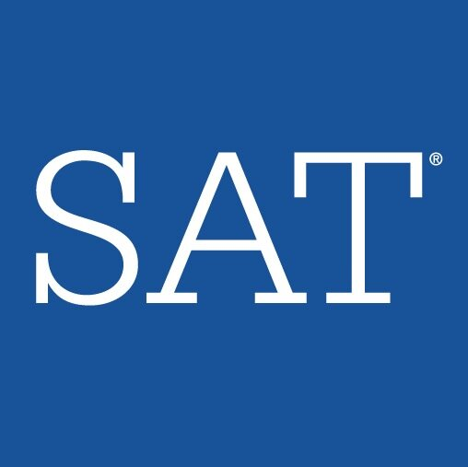](https://collegereadiness.collegeboard.org/sat?excmpid=VT-00051)

Click on the logo above or go to actstudent.org Click on the logo above or go to sat.org

Federal Aid- FAFSA

[Free Application for Federal Student Aid](https://fafsa.ed.gov/)

State of Florida- FFAA

[Florida Financial Aid Application](https://www.floridastudentfinancialaidsg.org/ua/sawstua_uaform.asp)

County- PEF

[Pasco Education Foundation](http://scholarships.pascoeducationfoundation.org/Account/Login?ReturnUrl=%2F)

[Local Scholarships](http://connectplus.pasco.k12.fl.us/asimons/local-and-degree-specific-scholarships/)

Senior Financial Aid Overview

Where to find aid?

April Simons

College & Career Specialist

Zephyrhills High School

[asimons@pasco.k12.fl.us](mailto:asimons@pasco.k12.fl.us)

813-794-6288

College & Career Website: <http://connectplus.pasco.k12.fl.us/asimons/>